**K L UNIVERSITY**

**FRESHMAN ENGINEERING DEPARTMENT**

**A Project Based Lab Report**

**On**

**Hotel Management System**

**SUBMITTED BY:**

I.D NUMBER NAME

170031340 V. Lohya Sujith

170031393 T. V. N. Akhilesh

170031356 V. Vali Sathish Reddy

170031397 Vinisha Vimal Kumar Shukla

**UNDER THE ESTEEMED GUIDANCE OF**

**Mr. B. Ashok**

**Assistant Professor**



**K.L.UNIVERSITY**

Green fields, Vaddeswaram – 522 502

Guntur Dt., AP, India.

**DEPARTMENT OF BASIC ENGINEERING SCIENCES**



**CERTIFICATE**

This is to certify that the project based laboratory report entitled “Hotel Management System” submitted by Mr./Ms**. V. Lohya Sujith, T.V.N. Akhilesh, V. Vali Sathish Reddy, Vinisha Vimal Kumar Shukla** bearing Regd. No. 170031340,170031393,170031356,170031397 to the **Department of Basic Engineering Sciences, K.L.University** in partial fulfillment of the requirements for the completion of a project based Laboratory in “C PROGRAMMING & DATA STRUCTURES LAB”course in I B Tech I Semester, is a bonafide record of the work carried out by him/her under my supervision during the academic year 2017 –18

Project Supervisor Head of the Department

B. Ashok Dr. D.HARITHA

**ACKNOWLEDGEMENTS**

It is great pleasure for me to express my gratitude to our honorable President **Sri. Koneru Satyanarayana**, for giving the opportunity and platform with facilities in accomplishing the project based laboratory report.

We express the sincere gratitude to our principal **Dr. A. Anand Kumar** for his administration towards our academic growth.

We express sincere gratitude to our Coordinator and HOD-BES **Dr. D.Haritha** for her leadership and constant motivation provided in successful completion of our academic semester. I record it as my privilege to deeply thank for providing us the efficient faculty and facilities to make our ideas into reality.

We express my sincere thanks to our project supervisor B.Ashok for his novel association of ideas, encouragement, appreciation and intellectual zeal which motivated us to venture this project successfully.

Finally, it is pleased to acknowledge the indebtedness to all those who devoted themselves directly or indirectly to make this project report

Name: Lohya Sujith - 170031340

T.V.N. Akhilesh- 170031393

V. Vali Sathish Reddy- 170031356

Vinisha Vimal Kumar Shukla-170031397

**ABSTRACT**

An application to be developed by the management system for a hotel with the following modules using structures, pointers to structure variables, passing structure pointers to function.

Design the program using these factors:

1. Get availability of the rooms in hotel.
2. Features of room in the hotel.
3. Collect the details of the customer.
4. Based on the interest of the customer room should be allocated.
5. Again, dellocate the room on the date the customer is leaving.
6. Finalize the bill of the customer including restaurant bill.

**INPUT:**

The input is categorized into two types

1. From the Management:

Know the availability of the rooms and also the features of the room in the hotel.

1. From the Customer:

Store the details of the customer and the number of days he is going to stay in hotel.

**OUTPUT:**

Charge of single day for the room choosen by the customer and his restaurant billings and the no of days he is going to stay in hotel and other expenses, are included in the final billing.

**INDEX**

|  |  |  |
| --- | --- | --- |
| **S.NO** | **TITLE** | **PAGE NO** |
| 1 | Introduction | 6 |
| 2 | Aim of the Project | 7 |
| 2.1 | Advantages & Disadvantages | 7 |
| 2.2 | Future Implementation | 8 |
| 3 | Software & Hardware Details | 8 |
| 4 | Data Flow Diagram | 9 |
| 5 | Implementation | 11 |
| 6 | Algorithm for each module | 16 |
| 7 | Integration and System Testing | 19 |
| 8 | Conclusion | 20 |

**INTRODUCTION**

In today’s world, the way of functioning and managing the system has been totally changed. There is a sudden and abrupt changes in the structure maintenance and modification, handling, leveling inside every system. Without managing system through computer applications and programming, the development of infrastructure are unfinished. There are many errors and drawback without use of computer programming and application.

As we know that, “necessity is the mother of invention”, so in today’s challenging world , every system is developed and launched by use of computer software and programming. As an customer and hotel are two related terms of business field, there should be proper way of management. The title of the project is related to the hotel i.e. “HOTEL MANAGEMENT SYSTEM”. hotel management deals with basic record of customer and staffs, room details, restaurant details, report etc. of the hotel.

Due to excessive growing number of hotels in the world, it is very enough to handle important files and data of the hotel correctly, efficiently and systematically. Location of this data may be inaccurate and difficult to access when they are required. So by use of Hotel Management system, user can easily maintain files and records in systematical way. Only authorized users are allowed to enter through the system .So the security is also maintained in the system.

Thus the hotel management system being one of the major necessity in today’s business field. So it can solve almost all the problem and can reached to each and every requirement of the user.

**AIM**

To develop an application for Hotel Management System with the following Modules using structures ,Pointers to Structure variables, passing structures pointers to functions

1. Get availability
2. Features of room
3. Room allocation
4. Show Customer details
5. Room deallocation
6. Restaurant
7. Billing

**Advantages**

There are many advantages of using this program :-

* Its actually a user friendly software as it is ease to use by just following the instructions as it is append on the screen
* In this program pointers are used to increase or decrease no. of rooms. So that it can be increased or decreased on its own.

**Disadvantages**

There are some disadvantages in this this application

* It cannot perform all the required functions as of professional one.
* System is not sharply a graphical user interface. There is just use of some colors and borders.
* It is not a multi-purpose and multi-tasking. It can’t perform various task at single time.

**Future enhancements**

Users can add extra enhancements in the system as per necessary in the future for the fulfilments of the requirements**.**

For the security purpose, advanced encryptions techniques can be applied.

**SYSTEM REQUIREMENTS**

* **Software Requirements:**

The major software requirements of the project are as follows:

Language : Turbo-C

Operating system**:** Windows Xp or later.

* **Hardware Requirements:**

The hardware requirements that map towards the software are as follows:

RAM : 2-GB

Processor : Intel C

**DATA FLOW DIAGRAM**

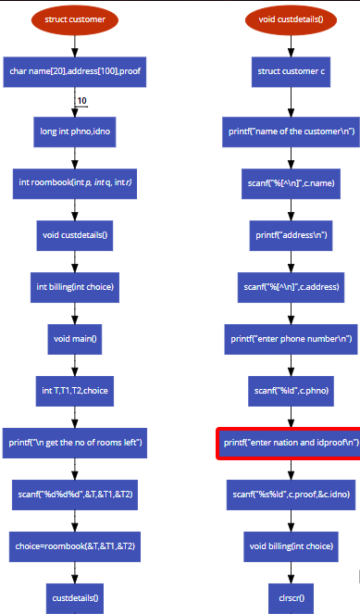

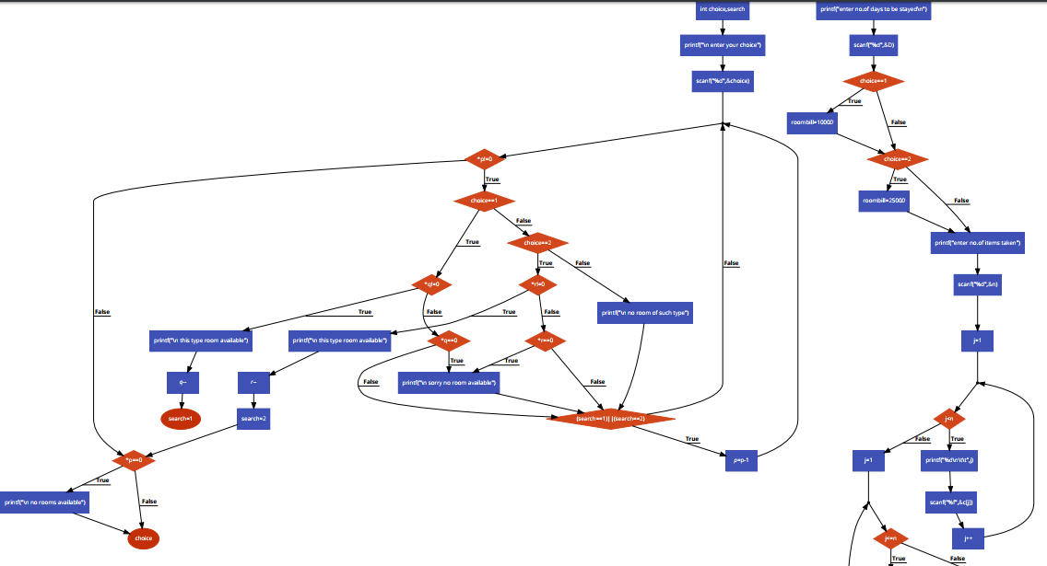

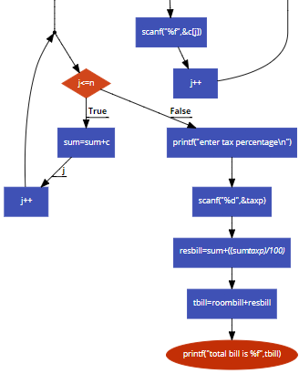

**IMPLEMENTATION**

#include<stdio.h>

#include<conio.h>

struct customer

{

char name[20],address[100],proof[10];

long int phno,idno;

};

int roombook(int *p, int *q, int *r);

void custdetails();

int billing(int choice);

void main()

{

int T,T1,T2,choice;

printf("\n get the no of rooms left");

scanf("%d%d%d",&T,&T1,&T2);

choice=roombook(&T,&T1,&T2);

custdetails();

billing(choice);

}

int roombook(int *p,int *q,int *r)

{

int choice,search;

printf("\n enter your choice");

scanf("%d",&choice);

while(*p!=0)

{

if(choice==1)

{

if(*q!=0)

{

printf("\n this type room available");

*q--;

search=1;

break;

}

if(*q==0)

{

printf("\n sorry no room available");

}

}

else if(choice==2)

{

if(*r!=0)

{

printf("\n this type room available");

*r--;

search=2;

break;

}

if(*r==0)

{

printf("\n sorry no room available");

}

}

else

{

printf("\n no room of such type");

}

if((search==1)||(search==2))

{

*p=*p-1;

}

}

if(*p==0)

{

printf("\n no rooms available");

}

return (choice);

}

void custdetails()

{

struct customer c;

printf("name of the customer\n");

scanf("%[^\n]",c.name);

printf("address\n");

scanf("%[^\n]",c.address);

printf("enter phone number\n");

scanf("%ld",c.phno);

printf("enter nation and idproof\n");

scanf("%s%ld",c.proof,&c.idno);

}

void billing(int choice)

{

clrscr();

int j,i[100],D,n,taxp;

float c[100],resbill,roombill,sum=0,tbill;

printf("enter no.of days to be stayed\n");

scanf("%d",&D);

if(choice==1)

{

roombill=1000*D;

}

if(choice==2)

{

roombill=2500*D;

}

printf("enter no.of items taken");

scanf("%d",&n);

for(j=1;j<n;j++)

{

printf("%d\n\t\t",j);

scanf("%f",&c[j]);

}

for(j=1;j<=n;j++)

{

sum=sum+c[j];

}

printf("enter tax percentage\n");

scanf("%d",&taxp);

resbill=sum+((sum*taxp)/100);

tbill=roombill+resbill;

printf("total bill is %f",tbill);

}

**ALGORITHM**

step 1:- start

step 2:- declare a structure customer name, address, proof, phone number, id.no

step 3:- declare functions roombook containing pointers *p,*q,*r

step 4:- declare function custdetails

step 5:- declare function billing

step 6:- read no of rooms left T,T1,T2,choice

step 7:- print no. of rooms left of each type

step 8:- read choice

pass choice into roombook function

step 9:- roombook function

step 10:-print the choice

step 11:-while(*p!=0)

{

if(choice==1)

{

if(*q!=0)

{

print rooms available

*q--;

search=1;

break;

}

else if(*q==0)

print no room available

}

else if(choice==2)

{

if(*r!=0)

{

print rooms available

*r--;

search=2;

break;

}

else

{

print room not availabe;

}

}

else

print no room of such type;

}

if(*p==0)

print no room available;

if(search==1||search==2)

*p--;

}

step 12:- read name of the customer

step 13:- read address

step 14:- read phone number

step 15:- read proof and id number of the proof of the customer

step 16:- read number of items taken

step 17:- read cost of each item

step 18:- calculate total cost of items taken

for(j=0;j<n;j++)

{

total=c[j];

}

step 19:-read number of days to be stayed

step 20:- if(choice==1)

roombill=1000*D;

else if(choice==2)

roombill=2500*D;

step 21:- read tax percentage

step 22:- calculate restaurant bill

restbill=total+(total*taxp/100);

step 23:- calculate total bill

tbill= resbill + roombill;

step 24: print total bill

**INTEGRATION AND SYSTEM TESTING**

**Output**

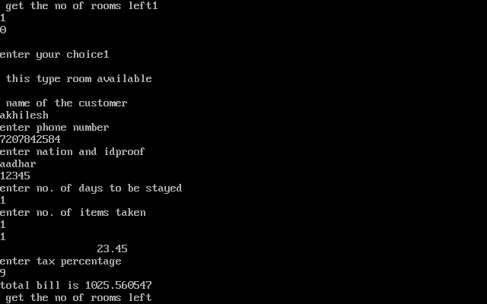

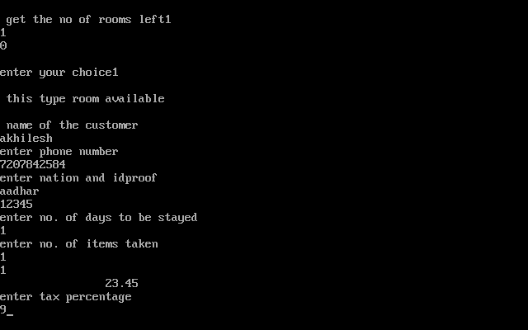

**CONCLUSION**

The hotel management has been developed, even if not totally flexible but it has the best flexibility and efficiency within the available resources and time. Every steps has been taken to initiate the existing manual system to make it more user friendly and to incorporate new features wherever necessary so that users could find the worth using the automated system.

The system is a highly user friendly , the menu and messages have been properly placed so as to make the user comfortable using the system . Frequently requested queries have been provided. Even a lay man can early use the system, after a small training .Whenever required the system can be expanded so incorporate new queries or modify the existing queries.

For the system maintenance and modification the source code has been properly documented which will make it easier for future modification of coding of required.